SQL Data Analysis Internship – Task 2

Schema for new table

USE StudentManagement;
CREATE TABLE IF NOT EXISTS Courses (
CourseID INT PRIMARY KEY AUTO_INCREMENT,
CourseName VARCHAR(50) NOT NULL
);
CREATE TABLE IF NOT EXISTS Enrollments (
StudentID INT,
CourseID INT,
Grade INT,
FOREIGN KEY (StudentID) REFERENCES Students(StudentID),
FOREIGN KEY (CourseID) REFERENCES Courses(CourseID)
);

Insert Sample Data

INSERT INTO Courses (CourseName) VALUES
('Mathematics'),
('Science'),
('English'),
('Computer Science'),
('History');
INSERT INTO Enrollments (StudentID, CourseID, Grade) VALUES
(1, 1, 85), (1, 2, 88), (1, 3, 83),
(2, 1, 95), (2, 2, 92), (2, 4, 90),
(3, 1, 70), (3, 3, 65), (3, 4, 72),
(4, 2, 89), (4, 3, 91), (4, 5, 87),
(5, 1, 55), (5, 4, 60), (5, 5, 58),
(6, 1, 78), (6, 2, 81), (6, 3, 79),
(7, 1, 94), (7, 2, 90), (7, 4, 97),
(8, 1, 62), (8, 3, 59), (8, 5, 61),
(9, 2, 76), (9, 3, 72), (9, 5, 74),
(10, 1, 98), (10, 2, 96), (10, 3, 97);

Queries
a. Students Enrolled in Each Course

SELECT
s.Name AS StudentName,
c.CourseName AS Course
FROM Enrollments e
JOIN Students s ON e.StudentID = s.StudentID
JOIN Courses c ON e.CourseID = c.CourseID
ORDER BY c.CourseName, s.Name;
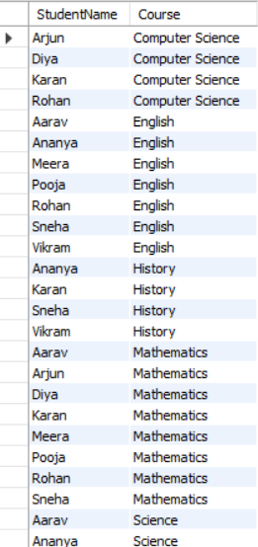
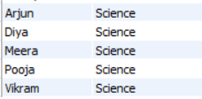

b. Average Grade per Course
SELECT
c.CourseName,
ROUND(AVG(e.Grade), 2) AS AverageGrade
FROM Enrollments e
JOIN Courses c ON e.CourseID = c.CourseID
GROUP BY c.CourseName
ORDER BY AverageGrade DESC;

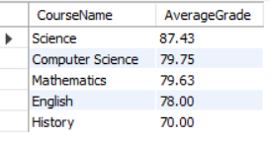

c. Top 3 Students Overall
SELECT
s.Name AS StudentName,
ROUND(AVG(e.Grade), 2) AS AvgGrade
FROM Enrollments e
JOIN Students s ON e.StudentID = s.StudentID
GROUP BY s.StudentID, s.Name
ORDER BY AvgGrade DESC
LIMIT 3;

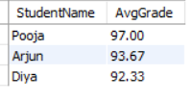
d. Count of Students Who Failed (Grade < 40)
SELECT
COUNT(DISTINCT StudentID) AS FailedStudents
FROM Enrollments
WHERE Grade < 40;

